INFORMATION SCIENCE AND ENGINEERING
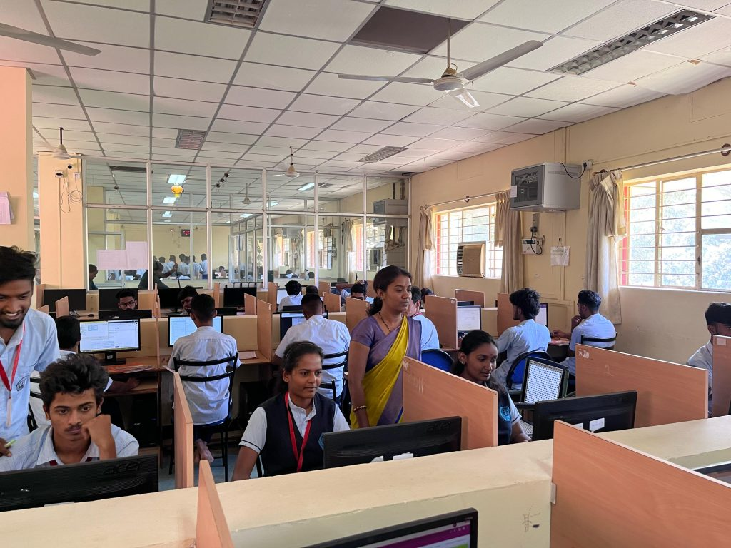
FROM HOD’S DESK
- The Department of Information Science and Engineering was established in the year 1987, recognized by DTE, Bengaluru and affiliated to AICTE, New Delhi. The current intake is 30 students.
- The department has well equipped computer facility with the latest hardware, software and peripherals with internet facilities.
- The students pursuing higher studies are studying in prestigious Engineering colleges like PESIT, SJCE, NIE etc…
- The department is dedicated to education and overall excellence.
- In addition to classes, students also have the opportunity to interact with faculty and supporting staff for mentoring.
- Staff and students are provided with unlimited free internet access at e-library during spare time, so that they can develop and enhance their knowledge acquired in class rooms.
VISION
To be recognized as a prestigious academic centre for excellence in technical education and to meet the needs of Academia, Industry & Society.
MISSION
- M1:To impart holistic outcome based education in both technical and non technical programs through state of the art curriculum and effective teaching-learning process.
- M2: To promote industry institutional collaboration through MOUs and internship programs.
- M3: To infuse ethical and responsible engineering practices to create successful professionals.
LIST OF TEACHING FACULTY
L No. | Image | NAME | DESIGNATION | QUALIFICATION | Date of Joining | Profile
1 |  | Tejaswini M P | HOD | MTech | 07-12-2007 | click here to view
2 | 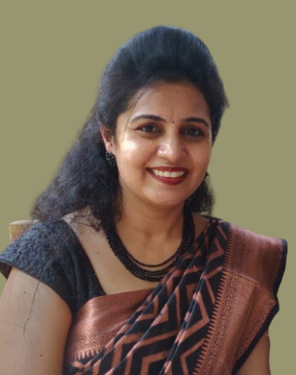 | Shruthi M | Lecturer | MTech | 08-06-2009 | click here to view
3 | 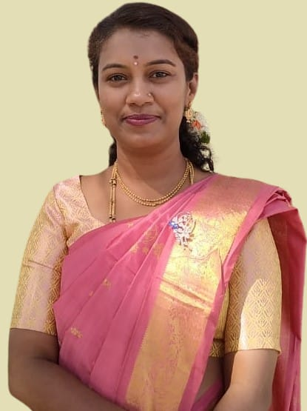 | Sowrabha MC | Lecturer | BE | 11-07-2022 | click here to view
4 | 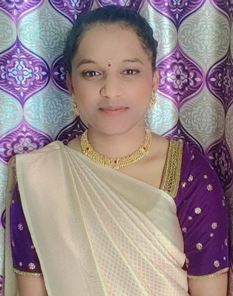 | Jayarajeshwari K | Lecturer | BE | 18/1/2024 | click here to view

LIST OF SUPPORTING STAFF
SL No. | Image | NAME | DESIGNATION | QUALIFICATION
1 | 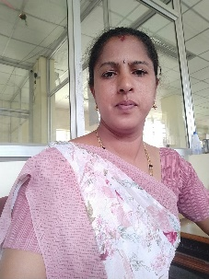 | Nagakanya M P | Lab helper | ITI
2 |  | Mahadevaswamy K N | Lab helper | ITI

